# Name: _______________ StudentID: ___________

## 

## Activity 1: Javascript runs Client side

Javascript is executed **client side**. What does this mean? How does it help the server?

It means that data are processed before sending to the server which would reduce the rate of overloading the server

### Server Side Validation

## 

### Client Side Validation

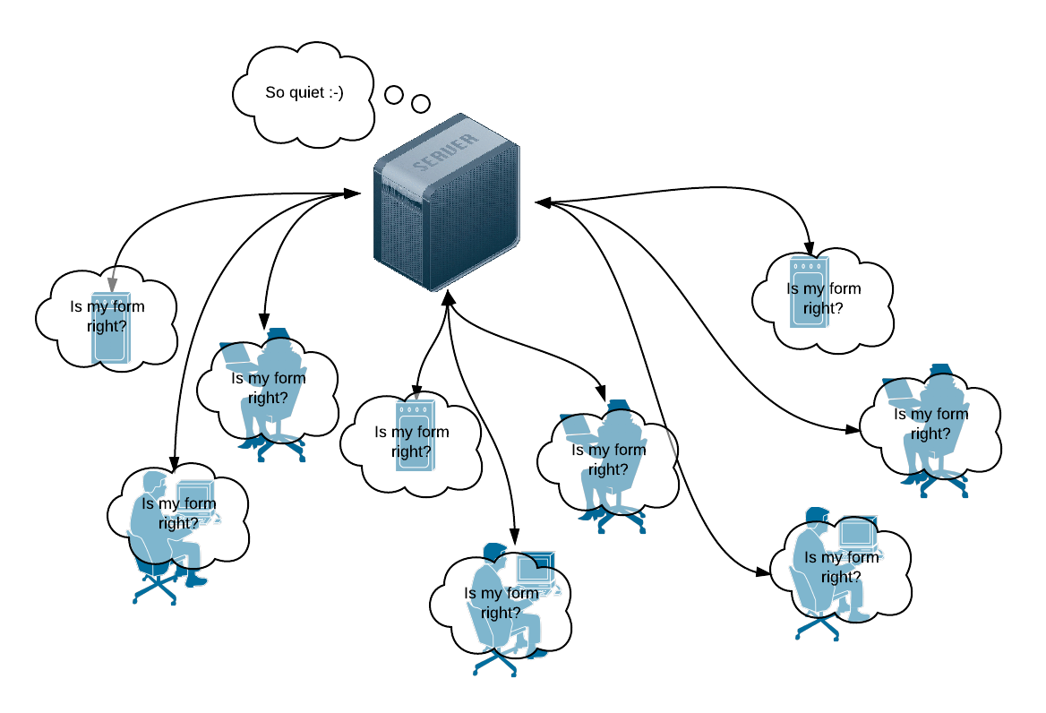

## Activity 2: Javascript Implementation

Javascript can be included into a html document in three ways: **External**, **Embedded** and **Inline;** and also into event handler attributes:

|  |
| --- |
| 1. <html> 2. <head> 3. <!-- External JS --> 4. <script type="text/javascript" src="tools.js"></script> 5. <!-- Embedded JS--> 6. <script type="text/javascript"> 7. function displayDate() { 8. document.getElementById("date").value = new Date(); 9. } 10. </script> 11. </head> 12. <body> 13. <h1>What's the Date?</h1> 14. <p><input type="text" id="date" name="date" value="Click the button" /> 15. <!-- Event handler JS --> 16. <button onclick="displayDate()">Display Date</button></p> 17. <p>&copy; Copyright Date Awareness Inc 1990 - 18. <script type="text/javascript"> 19. /* Inline JS */ 20. var d = new Date(); 21. document.write(d.getFullYear()); 22. </script> 23. <noscript>2001</noscript> 24. </p> 25. <h6>Ask us about the benefits of dynamic dating</h6> 26. </body> 27. </html> |

**Line 3:** External script. What sort of javascript code would you expect to find in tools.js?

All in text

**Lines 4 - 8 & 13:** Embedded script and event handler script: How is the function displayDate() called?

When user click on the element with id “date”

**Lines 19 - 22:** When does this code run? What does it show?

It will run after the code before it was executed but it won’t show anything, just change value of variable d

**Line 23:** Why do we need <noscript> tags? What will it show and when?

It shows 2001 when the browser doesn’t support javascript

## Activity 3: Responding to Events, running Functions

By now you should understand that every element can be given a unique id. The built in javascript function document.getElementById() can be used to:

* Return a reference to any element that has a unique id.
* Read, process and change values (even styles) dynamically.

The **button** generates a click event and calls a **function** in the previous example. In the lab we will also look at the onsubmit**,** onchange and onkeyupevents in the lab, but there are plenty of other events to look at.

Analyse this function. What does it do and how? When (and how) might you call it? Examine closely what the focus() and select() functions do in this code.

|  |
| --- |
| 1. // This function calculates a price for a cinema booking 2. function calculatePrice() 3. { 4. var numSeats = parseInt(document.getElementById('seats').value); 5. if (isNaN(numSeats)) 6. { 7. alert('You are a bad customer! Type numbers next time.'); 8. document.getElementById('seats').focus(); 9. document.getElementById('seats').select(); 10. return false; 11. } 12. var seatPrice = 20; 13. var salePrice = seatPrice * numSeats; 14. document.getElementById('price').innerHTML = salePrice.toFixed(2); 15. return true; 16. } |

* Check if the input is a number
* If it is not a number, give an error message.
* .focus() will automatically focus to input box (without user clicking the mouse on the input space)
* .select() will check the content of the input
* If it true, carry out the calculation

Why is using an alert box in a form validation script bad practice? What nicer methods can we use to alert users to errors? Think about your experience as a web user, what other ways have you been notified of errors on a web form?

Users will have to close the notice multiple times

We can notify the errors to user by changing the background color of the input space and have a line of text in read underneath input box to explain what error the user made.